Langflow
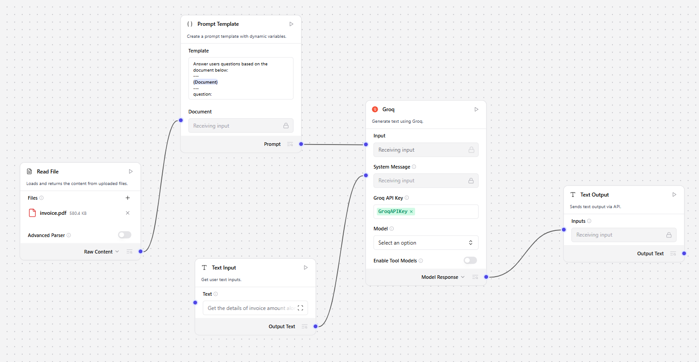
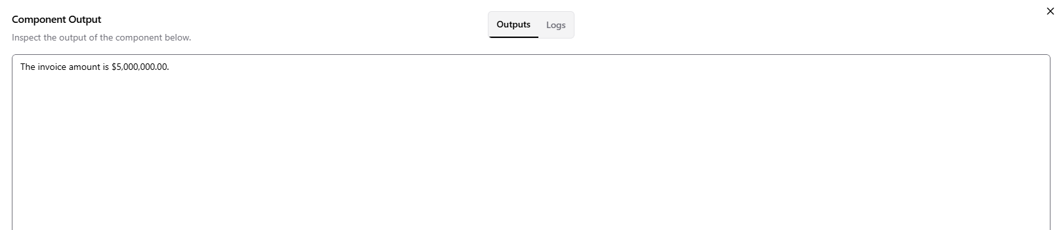

Request
{
"output_type": "text",
"input_type": "text",
"tweaks": {
"TextInput-FA8gq": {
"input_value": "Get the details of invoice amount alone"
},
"GroqModel-kJA4e": {
"api_key": "GroqAPIKey",
"base_url": "https://api.groq.com",
"model_name": "meta-llama/llama-4-scout-17b-16e-instruct"
}
}
}

Response
{
"session_id": "13dee481-ff33-4556-afe8-2246274584f8",
"outputs": [
{
"inputs": {},
"outputs": [
{
"results": {
"text": {
"text_key": "text",
"data": {
"text": "The invoice amount is $5,000,000.00.",
"files": [],
"sender": null,
"sender_name": null,
"session_id": "",
"context_id": "",
"timestamp": "2026-02-21 07:47:38 UTC",
"flow_id": "13dee481-ff33-4556-afe8-2246274584f8",
"error": false,
"edit": false,
"properties": {
"text_color": null,
"background_color": null,
"edited": false,
"source": {
"id": null,
"display_name": null,
"source": null
},
"icon": null,
"allow_markdown": false,
"positive_feedback": null,
"state": "complete",
"targets": []
},
"category": "message",
"content_blocks": [],
"duration": null
},
"default_value": "",
"text": "The invoice amount is $5,000,000.00.",
"sender": null,
"sender_name": null,
"files": [],
"session_id": "",
"context_id": "",
"timestamp": "2026-02-21T07:47:38+00:00",
"flow_id": "13dee481-ff33-4556-afe8-2246274584f8",
"error": false,
"edit": false,
"properties": {
"text_color": null,
"background_color": null,
"edited": false,
"source": {
"id": null,
"display_name": null,
"source": null
},
"icon": null,
"allow_markdown": false,
"positive_feedback": null,
"state": "complete",
"targets": []
},
"category": "message",
"content_blocks": [],
"duration": null
}
},
"artifacts": {
"text": {
"repr": "The invoice amount is $5,000,000.00.",
"raw": "The invoice amount is $5,000,000.00.",
"type": "text"
}
},
"outputs": {
"text": {
"message": "The invoice amount is $5,000,000.00.",
"type": "text"
}
},
"logs": {
"text": []
},
"messages": [
{
"message": "The invoice amount is $5,000,000.00.",
"sender": "Machine",
"sender_name": "AI",
"session_id": "",
"stream_url": null,
"component_id": "TextOutput-JrmI4",
"files": [],
"type": "text"
}
],
"timedelta": null,
"duration": null,
"component_display_name": "Text Output",
"component_id": "TextOutput-JrmI4",
"used_frozen_result": false
}
]
}
]
}

